

Lab 03 - Terraform

Submitted to: Tariq Ghouri



Submitted By:

Muhammad SOban Mallick – 2112158

Miuhammad Umer - 2112155

**Section 1: Parameterize Configuration**

#### **1. Create Files**

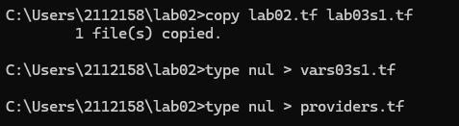

#### **2. Edit Files**

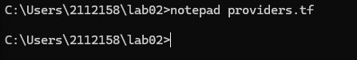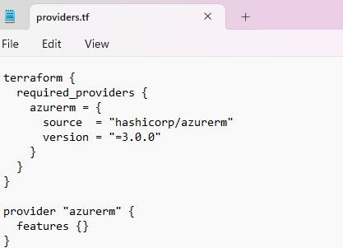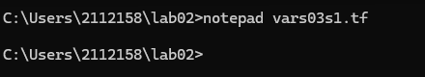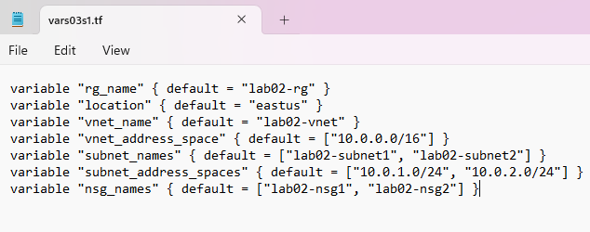

#### **3. Update lab03s1.tf**

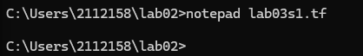

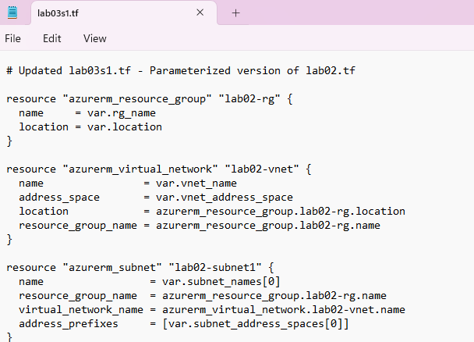

#### **4. Initialize & Deploy**

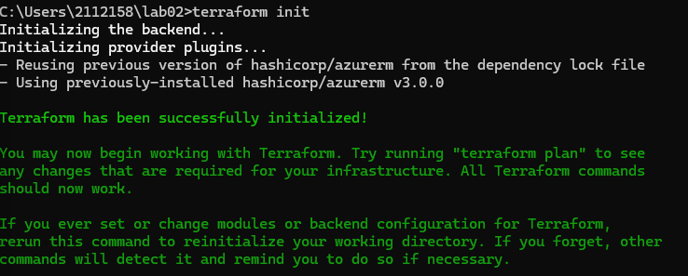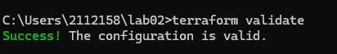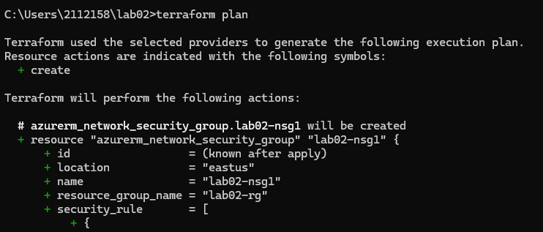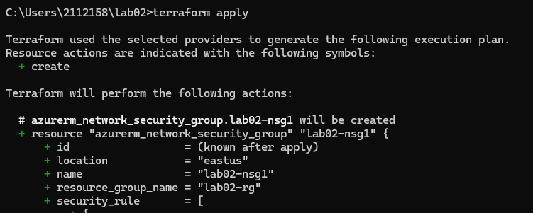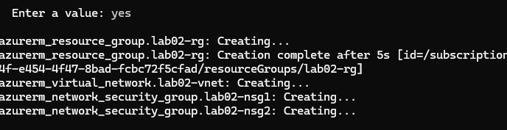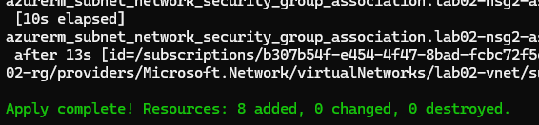

### ****Section 2: Add Linux VM****

#### **1. Create New Files**

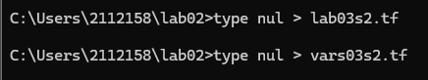

#### **2. Edit vars03s2.tf**

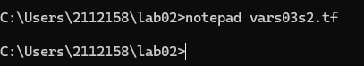

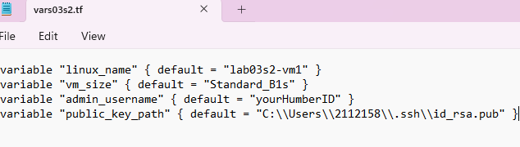

#### **4. Deploy VM**

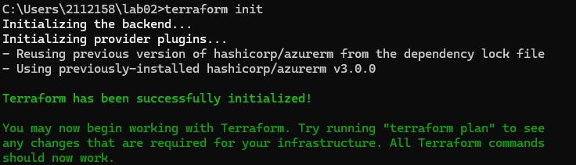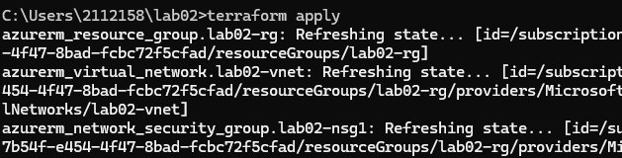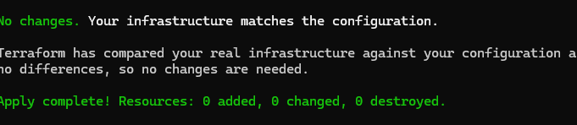

### ****Section 3: Local Values & Tags****

#### **Edit vars03s2.tf**

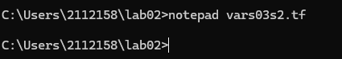

### 

#### **2. Update Resources**

### 

## Part 3: Update lab03s3.tf File

1. Open lab03s3.tf in a text editor and add tags to network interface, public IP, and virtual machine resource blocks using the locals values.

**SCREENSHOT of lab03s3.tf** (capture the full content in your editor).

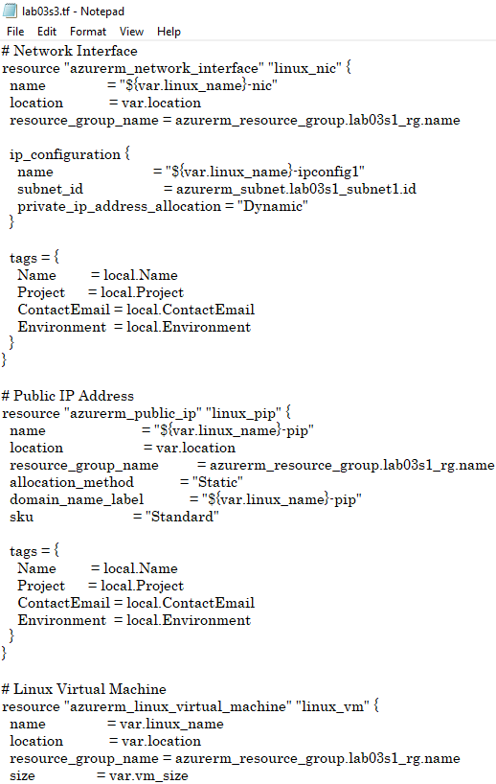

## 

## Part 4: Initialize Terraform

1. Initialize Terraform to download plug-ins as required:

## Part 5: Validate Configuration

1. Validate the configuration to ensure no errors or typos:
2. Fix any issues in the Terraform files if reported.
3. Re-run validation until no errors are reported:

**SCREENSHOT** (capture the successful validation output).

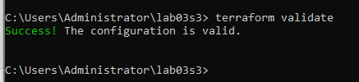

## Part 6: Run Simulation

1. Perform a dry run:

terraform plan

1. Review output and ensure all configuration meets requirements. Observe resources with +, -, or -/+ signs.
2. Fix any issues in the Terraform files if reported.
3. Redo the dry run until no errors are reported:

## Part 7: Deploy Infrastructure

1. Deploy the infrastructure and monitor progress:

terraform apply

* Type yes when prompted.

## Part 8: Get Information from Terraform State

1. View and analyze state information:

terraform state list terraform show

**SCREENSHOT** (capture both outputs).

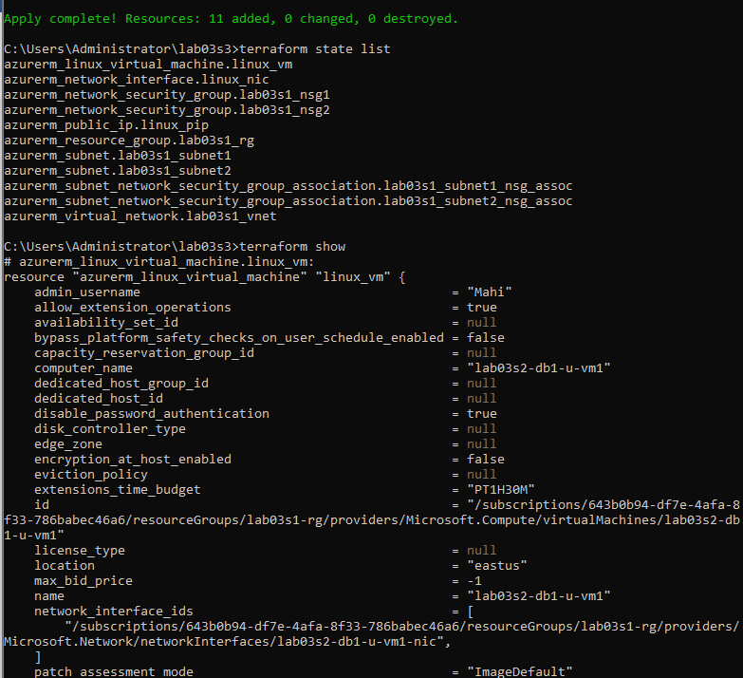

## Part 9: Confirm Resource Creation in Azure

1. Log in to the Azure Portal. Navigate to the resource group and confirm all resources and tags exist as per specifications.

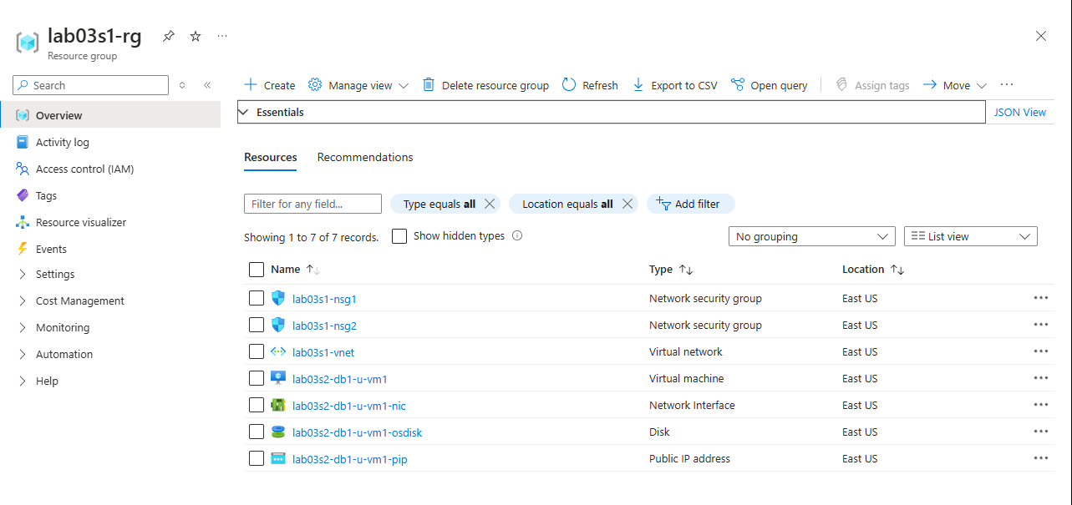**SCREENSHOT** (capture the Azure Portal showing resources and tags).

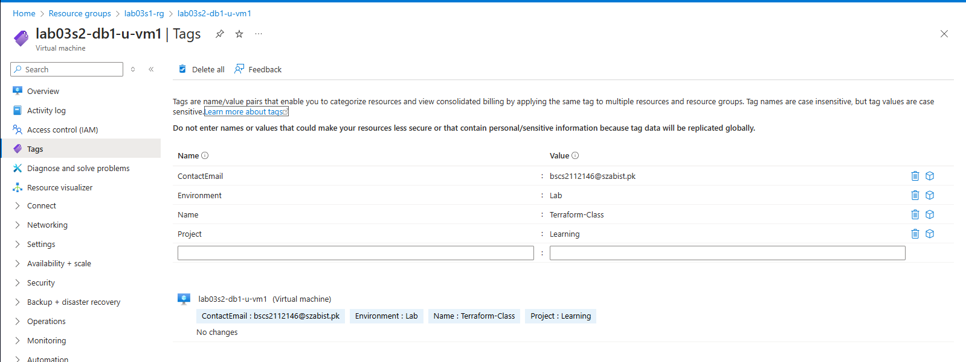

## Part 10: Destroy All Resources and Verify

1. Destroy all resources:

terraform destroy

* + Type yes when prompted.

1. Verify deletion:

terraform state list terraform show

**SCREENSHOT** (capture both outputs).

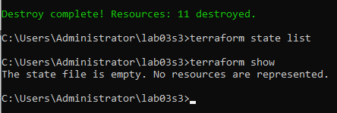

# Section 4

## Objectives:

* Use configuration from Section 3.
* Define output blocks to display values.
* Validate, deploy, expand, analyze, and destroy infrastructure.

## Part 1: Prepare for the Lab

1. Copy the lab03s3 directory as lab03s4:
2. Change into the lab03s4 directory:
3. Create an empty file called outputs03s4.tf:

## Part 2: Update outputs03s4.tf File

1. Open outputs03s4.tf in a text editor and define output blocks to display:
   1. VM hostname (1 block).
   2. Private IP address (1 block) and Public IP address (1 block).
   3. Virtual network name (1 block) and address space (1 block).
   4. Subnet names (2 blocks) and address spaces (2 blocks).

**SCREENSHOT of outputs03s4.tf** (capture the full content in your editor).

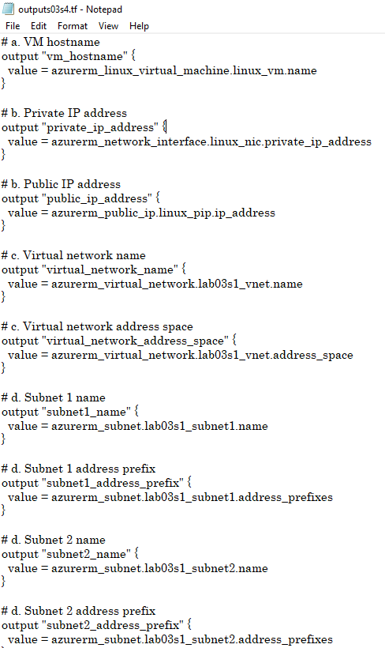

## Part 3: Validate Configuration

1. Validate the configuration to ensure no errors or typos:
2. Fix any issues in the Terraform files if reported.
3. Re-run validation until no errors are reported:

**SCREENSHOT** (capture the successful validation output).



## Part 4: Run Simulation

1. Perform a dry run:

terraform plan

1. Review output and ensure all configuration meets requirements. Observe resources with +, -, or -/+ signs.
2. Fix any issues in the Terraform files if reported.
3. Redo the dry run until no errors are reported:

## Part 5: Deploy Infrastructure

1. Deploy the infrastructure and monitor progress:

terraform apply

* Type yes when prompted.

1. Confirm output values displayed on the screen at the end of deployment.

## Part 6: Get Information from Terraform State

1. View and analyze state information:

terraform state list terraform show

**SCREENSHOT** (capture both outputs).

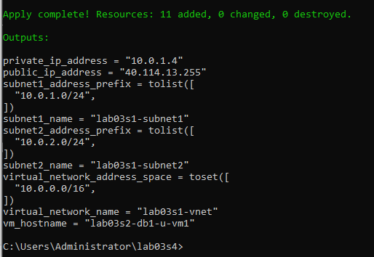

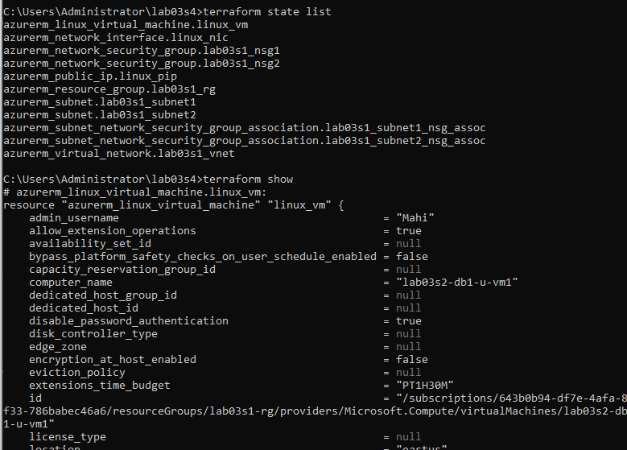

## Part 7: Display Output Information

1. Display output information:

terraform output

**SCREENSHOT** (capture the output).

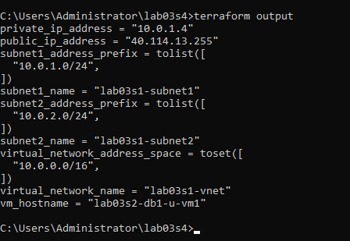

## Part 8: Destroy All Resources and Verify

1. Destroy all resources:

terraform destroy

* Type yes when prompted.

1. Verify deletion:

terraform state list terraform show

**SCREENSHOT** (capture both outputs).

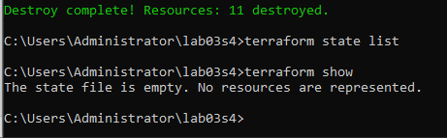

# Section 5

## Objectives:

* Use configuration from Section 4.
* Define lifecycle rules to prevent updates and resource deletions.
* Define explicit dependency.
* Validate, deploy, expand, analyze, and destroy infrastructure.

## Part 1: Prepare for the Lab

1. Copy the lab03s4 directory as lab03s5:
2. Change into the lab03s5 directory:
3. Rename lab03s3.tf as lab03s5.tf:

## Part 2: Update lab03s5.tf File

1. Open lab03s5.tf in a text editor and define an explicit dependency rule for the virtual machine to wait for the creation of the resource group.

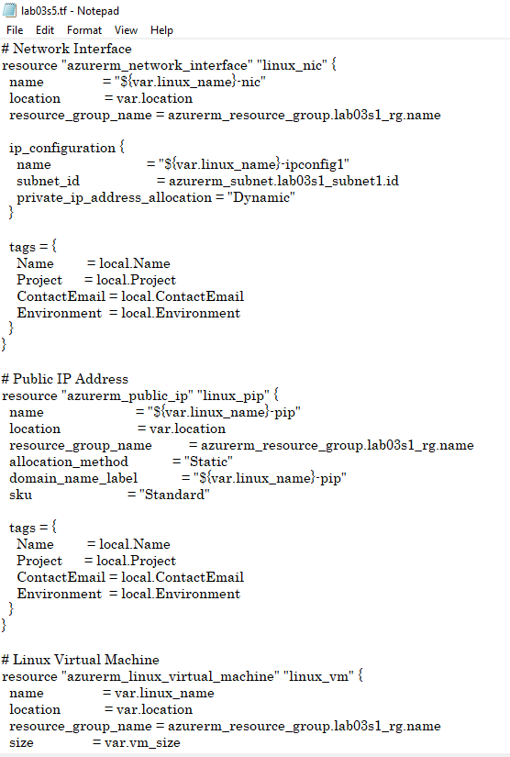**SCREENSHOT of lab03s5.tf** (capture the full content in your editor).

## 

## Part 3: Validate Configuration

1. Validate the configuration to ensure no errors or typos:
2. Fix any issues in the Terraform files if reported.
3. Re-run validation until no errors are reported:

**SCREENSHOT** (capture the successful validation output).



## Part 4: Run Simulation

1. Perform a dry run:

terraform plan

1. Review output and ensure all configuration meets requirements. Observe resources with +, -, or -/+ signs.
2. Fix any issues in the Terraform files if reported.
3. Redo the dry run until no errors are reported:

## Part 5: Deploy Infrastructure

1. Deploy the infrastructure and monitor progress:

terraform apply

* + Type yes when prompted.

1. Confirm output values displayed on the screen at the end of deployment.

## Part 6: Add and Test a Lifecycle Deletion Rule

1. Edit lab03s5.tf in a text editor and add a rule to prevent virtual machine, public IP, and network interface resources from removal (use lifecycle { prevent_destroy = true }).
2. Run:

terraform destroy

* Observe the error message generated.

**SCREENSHOT** (capture the error output).

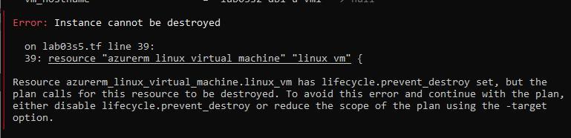

1. Edit lab03s5.tf again and remove the deletion rules.

*Do not destroy the infrastructure yet.*

## Part 7: Add and Test a Lifecycle Update Rule

1. Go to the Azure Portal and change some tag values for the virtual machine.
2. Edit lab03s5.tf in a text editor and add a rule to prevent tag updates to the virtual machine (use lifecycle { ignore_changes = [tags] }).
3. Run:

terraform plan

* Observe the dry run output.

**SCREENSHOT** (capture the output).

1. 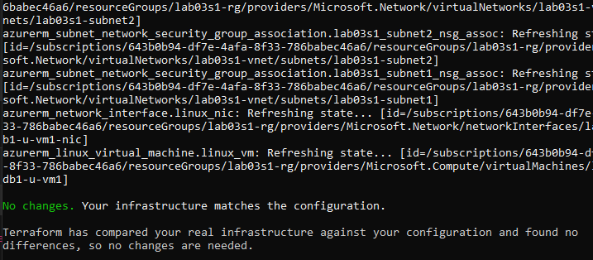Edit lab03s5.tf again and remove the update rule.

## Part 8: Display Dependency Graph

1. Show dependency tree:

terraform graph

**SCREENSHOT** (capture the output).

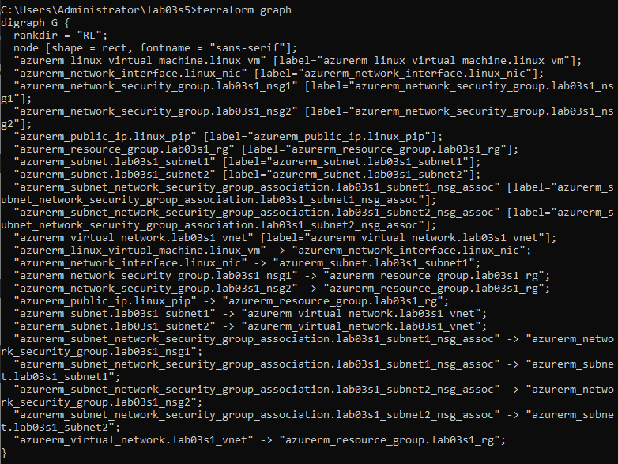

## Part 9: Destroy All Resources and Verify

1. Destroy all resources:

terraform destroy

* Type yes when prompted.

1. Verify deletion:

terraform state list terraform show